## VISVESVARAYA TECHNOLOGICAL UNIVERSITY

### “Jnana Sangama”, Belagavi , Karnataka, INDIA



A Project Report on

***“Voice Based Email Application for Visually Impared Person”***

*Submitted in partial fulfillment of the requirement for the award of the degree of*

#### Bachelor of Engineering in

**Computer Science and Engineering**

*Submitted By*

|  |  |
| --- | --- |
| **Chandan S** | **1GA18CS044** |
| **Dhamini BV** | **1GA18CS051** |
| **Dhanush R** | **1GA18CS052** |

*Under the Guidance of*

**Mr Rudramurthy V.C**

Assistant Professor



### Department of Computer Science and Engineering

**Accredited by NBA(2019-2022)**

## GLOBAL ACADEMY OF TECHNOLOGY

Rajarajeshwarinagar, Bengaluru - 560 098

**2021 – 2022**

## Department of Computer Science and Engineering

**Accredited by NBA(2019-2022)**



# CERTIFICATE

Certified that the Project Entitled **“Voice Based Email Application for Visually Impared person”** carried out by **Chandan S**, bearing **USN 1GA18CS044, Dhamini BV**, bearing **USN 1GA18CS051, Dhanush R**, bearing **USN 1GA18CS052,** bonafide students of Global Academy of Technology, is in partial fulfillment for the award of the **BACHELOR OF ENGINEERING** in **Computer Science and Engineering** from Visvesvaraya Technological University, Belagavi during the year 2021-2022. It is certified that all the corrections/suggestions indicated for Internal Assessment have been incorporated in the report submitted to the department. The Partial Project report has been approved as it satisfies the academic requirements in respect of the project work prescribed for the said Degree.

Guide Name Designation Dept. of CSE GAT, Bengaluru.

Dr. Bhagyashri R Hanji Professor & HOD Dept. of CSE

GAT, Bengaluru.

Dr. Rana Pratap Reddy Principal

GAT, Bengaluru.

Rajarajeshwarinagar, Bengaluru – 560 098



# DECLARATION

We, **Chandan S**, bearing **USN 1GA18CS044, Dhamini BV**, bearing **USN 1GA18CS051, Dhanush R**, bearing **USN 1G18CS052**, students of Seventh Semester B.E, Department of Computer Science and Engineering, Global Academy of Technology, Rajarajeshwarinagar Bengaluru, declare that the Project Work entitled “**Voice Based Email Application for Visually Impared Person”** has been carried out by us and submitted in partial fulfillment of the course requirements for the award of degree in **Bachelor of Engineering** in **Computer Science and Engineering** from **Visvesvaraya Technological University, Belagavi** during the academic year **2021-2022**.

|  |  |  |
| --- | --- | --- |
| 1.Chandan S | 1GA18CS044 | Signature |
| 2.Dhamini BV | 1GA18CS051 | Signature |
| 3.Dhanush R | 1GA18CS052 | Signature |

**Place: Bengaluru Date:**

# ABSTRACT

With the advent of technologies in computer, many technological solutions have been implemented for visually impaired so that they can utilize them, and get benefited by them. Considering it as a key idea we have built a desktop application that will help blind people to send and read emails as ordinary people do. In this research paper we describe the VMAIL system architecture for Python platform that can be used by a Blind Person to access e-mails easily. The application uses ‘text to speech’ and voice recognizer to facilitate sending, reading, emails using an computer. Internet has become one of the basic amenities for day-to- day living. Every human being is widely accessing the knowledge and information through internet. However, blind people face difficulties in accessing these text materials, also in using any service provided through internet. The advancement in computer based accessible systems has opened up many avenues for the visually impaired across the globe in a wide way. Audio feedback based virtual environment like, the screen readers have helped Blind people to access internet applications immensely. We describe the Voicemail system architecture that can be used by a Blind person to access e-Mails easily and efficiently.

The satisfaction and the euphoria that accompany the successful completion of any task would be incomplete without the mention of the people who made it possible. The constant guidance of these persons and encouragement provide, crowned our efforts with success and glory. Although it is not possible to thank all the members who helped for the completion of the phase - 1 of project individually, we take this opportunity to express our gratitude to one and all.

We are grateful to management and our institute **GLOBAL ACADEMY OF TECHNOLOGY** with its very ideals and inspiration for having provided us with the facilities, which made this, phase - 1 project a success.

We express our sincere gratitude to **Dr. N. Rana Pratap Reddy,** Principal, Global Academy of Technology for the support and encouragement.

We wish to place on record, our grateful thanks to **Dr. Bhagyashri R Hanji** Professor and HOD, Department of CSE , Global Academy of Technology, for the constant encouragement provided to us.

We are indebted with a deep sense of gratitude for the constant inspiration, encouragement, timely guidance and valid suggestion given to us by our guide **Mr Rudramurthy V.C, Assistant Professor**, Department of CSE, Global Academy of Technology.

We are thankful to all the staff members of the department for providing relevant information and helped in different capacities in carrying out this phase -1 project.

Last, but not least, we owe our debts to our parents, friends and also those who directly or indirectly have helped us to make the phase - 1 project work a success.

|  |  |
| --- | --- |
| **CHANDAN S** | **1GA18CS044** |
| **DHAMINI BV** | **1GA18CS051** |
| **DHANUSH R** | **1GA18CS052** |

|  |  |  |
| --- | --- | --- |
| **Chapter No.** | **Particulars** | **Page. No** |
|  | Abstract | i |
|  | Acknowledgement | ii |
|  | Table of contents | iii |
|  | List of Figures | V |
|  | List of Tables | vi |
|  | Glossary | vii |
| 1 | Introduction | 11 |
| 1.1 | Definitions | 11 |
| 1.2 | Project Report Outline | 13 |
| 2 | Review of Literature | 14 |
| 2.1 | System Study | 15 |
| 2.2 | Proposed Work | 17 |
| 2.3 | Scope of the project | 17 |
| 3 | System Requirement Specification | 18 |
| 3.1 | Functional Requirements | 18 |
| 3.2 | Non Functional Requirements | 19 |
| 3.3 | Hardware Requirements | 19 |
| 3.4 | Software Requirements | 21 |
| 4 | System Design | 24 |

|  |  |  |
| --- | --- | --- |
| 4.1 | Design Overview | 24 |
| 4.2 | System Architecture | 24 |
| 4.3 | Data Flow Diagrams | 25-26 |
| 4.3.1 | Data Flow Diagram - Level 0 |  |
| 4.3.2 | Data Flow Diagram - Level 1 |  |
| 4.3.3 | Data Flow Diagram - Level 2 |  |
| 4.4 | Use Case Diagram | 26 |
| 4.5 | Class Diagram | 27 |
| 4.6 | Sequence Diagram | 27 |
| 4.7 | Collaboration Diagram | 28 |
| 4.8 | Activity Diagram | 28 |
| 4.9 | Modules | 29-30 |
| 4.9.1 | Name of the Module |  |
| 4.9.2 | Name of the Module |  |
| 5 | Conclusion | 31 |
|  | Bibliography | 32 |

|  |  |  |
| --- | --- | --- |
| **Figure No.** | **Figure Name** | **Page. No** |
| Figure 4.1 | System Architecture | 24 |
| Figure 7.2 | Admin login page | 45 |

|  |  |  |
| --- | --- | --- |
| **Table No.** | **Table Name** | **Page. No** |
| Table 3.1 | Non Functional Requirements | 5 |
| Table 3.2 | Test cases for login page | 55 |

|  |  |
| --- | --- |
| SRS | Software Requirement Specification |
| DFD | Data Flow Diagram |
| TCP | Transmission Control Protocol |

**CHAPTER 1**

**INTRODUCTION**

The most common mail services that are used in our day to day life cannot be used by visually challenged people. To make these systems convenient for these people who are visually challenged there are various technologies provided to them like screen reader, automatic speech recognizer, speech to text and text to speech, braille keyboard, etc. However, these technologies are not that much useful for those people as it could not give the proper response like a normal system. The objective of Voice Based Email for Visually Impaired is to help challenge one’s access mails easily and efficiently. This application is based on using speech-to-text and text-to-speech converters, thus enabling everyone to control their mail accounts using their voice only and be able to read, send, and perform all the other useful tasks. The system will prompt the user with voice commands to perform certain action and the user will respond to the same. So here put to use are the Speech-to-Text and Text-to-Speech technologies using .net framework. The Speech-to-Text also known as Automatic Speech Recognition converts spoken speech into text, which helps compose emails as an easy task. The Text-to-Speech module gives audio output of the mail received, the sender, the subject and the body of the mail is read out by the system. Along with it, the aim is to provide assistance to use fundamental applications like My Computer, Word, Notepad, etc.

### Definitions

#### Text-to-Speech:

Google Cloud Text-to-Speech enables developers to synthesize natural-sounding speech with 100+ voices, available in multiple languages and variants. It applies DeepMind’s ground breaking research in WaveNet and Google’s powerful neural networks to deliver the highest fidelity possible. As an easy-to-use API, you can create lifelike interactions with your users, across many applications and devices.

#### Speech-to-Text

Speech recognition is an interdisciplinary subfield of computer science and computational linguistics that develops methodologies and technologies that enable the recognition and translation of spoken language into text by computers with the main benefit of searchability.

#### Face Recognition:

A facial recognition system is a technology capable of matching a human face from a digital image or a video frame against a database of faces, typically employed to authenticate users through ID verification services, works by pinpointing and measuring facial features from a given image.

#### Problem Formation:

Electronic mail i.e. email is the most important part in day to day life. But some of the people in today’s world don’t know how to make use of internet, some are blind or some are illiterate. So it goes very difficult to them when to live in this world of internet. Nowadays there are various technologies available in this world like screen readers, ASR, TTS, STT, etc. but these are not that much efficient for them. Around 39 million people are blind and 246 people have low vision and also 82 of people living with blindness are 50 aged and above.

In the previous system with the help of screen readers it is difficult for blind person to access E-mail system and computer operating easily because it has noisy audio interface. These available systems require use of keyboard which is very difficult for blind people to recognize and remember characters of keyboard. So we implement voice based E-mail system for blind person and it also helps handicapped and illiterate people.

#### Motivation:

Voice based E-mail system architecture that can be used by a Blind person to access E- mails easily and efficiently. The contribution made by this research has enabled the Blind people to send and receive voice based e- Mail messages in their native language with the help of a computer or a mobile device.

#### OBJECTIVE OF THE PROJECT:

* + - This project aims at developing an email system that will help even a naïve, visually impaired person to use the services for communication without previous training.
    - The system does not require the use of keyboard. Instead it will work only on mouse operations and speech conversion to text.
    - To build an architecture used by blind people to access E-mail and multimedia functions of operating system easily and efficiently.
    - To build a secure authentication system while login.

### Project Report Outline

The project report is organized as follows:

#### Chapter 1-Introduction

This chapter tells about the problem statement, background of the project, motivation, problem statement and scope of the project with its theoretical outline.

#### Chapter 2- Literature review

Gives brief overview of the paper and the research sources that have been studied to establish through an understanding of the under consideration. Existing system, proposed system, scope of the project.

#### Chapter 3-System Requirement Specification

Gives brief overview of the paper and the research sources that have been studied to establish through an understanding of the under consideration.

#### Chapter 4- System Design

Discuss in detail about the different kind of requirement needed t successfully complete the project.

#### Chapter 5-Conclusion:

Gives the conclusion of our work done so far.

* **Bibliography:**

### SUMMARY

This chapter tells about the problem statement, background of the project, motivation, problem statement and objective of the project and about how we use this information to develop the project that helps blind people to access the email.

## CHAPTER-2

**REVIEW OF LITERATURE**

A literature survey or a literature review in a project report shows the various analyses and research made in the field of interest and the results already published, taking into account the various parameters of the project and the extent of the project. Literature survey is mainly carried out in order to analyze the background of the current project which helps to find out flaws in the existing system & guides on which unsolved problems we can work out. So, the following topics not only illustrate the background of the project but also uncover the problems and flaws which motivated to propose solutions and work on this project.

A literature survey is a text of a scholarly paper, which includes the current knowledge including substantive findings, as well as theoretical and methodological contributions to a particular topic. Literature reviews use secondary sources, and do not report new or original experimental work. Most often associated with academic-oriented literature, such as a thesis, dissertation or a peer-reviewed journal article, a literature review usually precedes the methodology and results sectional though this is not always the case. Literature reviews are also common in are search proposal or prospectus (the document that is approved before a student formally begins a dissertation or thesis). Its main goals are to situate the current study within the body of literature and to provide context for the particular reader. Literature reviews are a basis for researching nearly every academic field. demic field. A literature survey includes the following:

* + Existing theories about the topic which are accepted universally.
  + Books written on the topic, both generic and specific.
  + Research done in the field usually in the order of oldest to latest.
  + Challenges being faced and on-going work, if available.

Literature survey describes about the existing work on the given project. It deals with the problem associated with the existing system and also gives user a clear knowledge on how to deal with the existing problems and how to provide solution to the existing problems.

### Objectives of Literature Survey

* + Learning the definitions of the concepts.
  + Access to latest approaches, methods and theories.
  + Discovering research topics based on the existing research
  + Concentrate on your own field of expertise– Even if another field uses the same words, they usually mean completely.
  + It improves the quality of the literature survey to exclude sidetracks– Remember to explicate what is excluded.

### System Study

Before building our application, the following systems are taken into consideration:

#### Topic: Novel Method using Beacon and Smart Phone for Visually Impaired/ Blind People

**Author: Ayad E. Korial, Mohammed N. Abdullah**

**Abstract:** This paper presents novel structure for visually impaired/blind people using beacon and smart phone. The proposed structure is consisted of three parts. In the first part esp8266 module due to ultra-low power consumption, in the second part configurator application to configure these beacon and last part is mobile application to detect these beacons. The aim is to help visually impaired/blind people to knowledge the environment in which they live by. Three tests applied in real environment. The results show good performance for the suggested scheme help the visually impaired/blind people reach the desired devices location successfully without error. In conclusion, beacon and smart phone were a valid and reliable method to help the visually impaired/blind people to know the location of devices that are nearest from him in indoor environment.

#### Topic: Location Based Service using Android Internet Multimedia Service Architecture and Applications

**Author: S. Kumar**

**Abstract:** Initially mobile phones were developed only for voice communication but now days the scenario has changed, voice communication is just one aspect of a mobile phone. There are other aspects which are major focus of interest. Two such major factors are web browser and GPS services. Both of these functionalities are already implemented but are only

in the hands of manufacturers not in the hands of users because of proprietary issues, the system does not allow the user to access the mobile hardware directly. But now, after the release of android based open source mobile phone a user can access the hardware directly and design customized native applications to develop Web and GPS enabled services and can program the other hardware components like camera etc. In this paper we will discuss the facilities available in android platform for implementing LBS services (geo-services).

#### Topic: Improving the Accessibility of NFC/RFID-based Mobile Interaction through Learnability and Guidance

**Author: G. Broll, S. Keck, P. Holleis and A. Butz**

**Abstract:** NFC and RFID technologies have found their way into current mobile phones and research has presented a variety of applications using NFC/RFID tags for interaction between physical objects and mobile devices. Since this type of interaction is widely novel for most users, there is a considerable initial inhibition threshold for them. In order to get novice users started with this physical interaction and its applications, we have designed different ways to increase the learnability and guidance of such applications. Their effectiveness was evaluated in a qualitative and quantitative user study with 40 participants, who interacted with NFC- equipped posters in different ways. We report on the types of usage errors observed and show that future designs of NFC/RFID-based mobile applications should consider using a dedicated start-tag for interaction.

#### Topic: Voice based email system for blinds Author: T. Shabana, A. Anam, A. Rafiya, K. Aisha,

**Abstract:** In today’s world communication has become so easy due to integration of communication technologies with internet. However the visually challenged people find it very difficult to utilize this technology because of the fact that using them requires visual perception. Even though many new advancements have been implemented to help them use the computers efficiently no naïve user who is visually challenged can use this technology as efficiently as a normal naïve user can do that is unlike normal users they require some practice for using the available technologies. This paper aims at developing an email system that will help even a naïve visually impaired person to use the services for communication without previous training. The system will not let the user make use of keyboard instead will work only on mouse operation and speech conversion to text. Also this system can be used by any normal person also for example the one who is not able to read. The system is completely based on interactive voice response which will make it user friendly and efficient to use.

### Proposed Work

We propose a voice mail architecture used by blind people to access E-mail and multimedia functions of operating system easily and efficiently. This architecture will also reduce cognitive load taken by blind to remember and type characters using keyboard. It also helps handicapped and illiterate people. It provides the secure authentication using face recognition. Results illustrate that the proposed model provides high accuracy compared to existing models.

### Scope of the project

It will be useful for the community so that people with disabilities to develop on the side of the village. This project allows people with visual impairments to be quite capable of being a part of the growth of digital India and on their ability to communicate over the Internet and in people's lives easier. This system overcomes many of the disadvantages of the people down your face when you see how to send and receive email. The success of this project can affect the developers, encouraging them to create useful products that can help people with low vision or who are blind.

#### SUMMARY

This chapter tells about literature summary, proposed system and scope of the project that predicts the cryptocurrency price.

### CHAPTER-3

**System Requirement Specification**

System Requirement Specification (SRS) is a central report, which frames the establishment of the product advancement process. It records the necessities of a framework as well as has a depiction of its significant highlight. An SRS is essentially an association's seeing (in composing) of a client or potential customer's frame work necessities and conditions at a specific point in time (generally) before any genuine configuration or improvement work. It's a two-way protection approach that guarantees that both the customer and the association comprehend alternate's necessities from that viewpoint at a given point in time.

The SRS talks about the item however not the venture that created it, consequently the SRS serves as a premise for later improvement of the completed item. The SRS may need to be changed, however it does give an establishment to proceed with creation assessment. In straightforward words, programming necessity determination is the beginning stage of the product improvement action.

The SRS means deciphering the thoughts in the brains of the customers – the information, into a formal archive – the yield of the prerequisite stage. Subsequently the yield of the stage is a situated of formally determined necessities, which ideally are finished and steady, while the data has none of these properties.

### Functional Requirements

This section describes the functional requirements of the system for those requirements which are expressed in the natural language style.

* + 1. Create a Desktop application using Tkinter.
    2. User should register and login to the application by giving voice input and provides high security based on face recognition.
    3. System will understand the voice input.
    4. System will generate and interact with the user based on their voice commands it will generates the voice output.
    5. Application should accurately recognize the voice commands and respond to the user automatically.

### Non Functional Requirements

These are requirements that are not functional in nature, that is, these are constraints within which the system must work.

* The program must be self-contained so that it can easily be moved from one Computer to another. It is assumed that network connection will be available on the computer on which the program resides.
* Capacity, scalability and availability.

The system shall achieve 100 per cent availability at all times.

The system shall be scalable to support additional clients and volunteers.

#### Maintainability.

The system should be optimized for supportability, or ease of maintenance as far as possible. This may be achieved through the use documentation of coding standards, naming conventions, class libraries and abstraction.

#### Randomness, verifiability and load balancing.

The system should be optimized for supportability, or ease of maintenance as far as possible. This may be achieved through the use documentation of coding standards, naming conventions, class libraries and abstraction. It should have randomness to check the nodes and should be load balanced.

### Hardware Requirements

* System : Intel I5.
* Hard Disk : 120 GB.
* Monitor : 15’’ LED
* Input Devices : Keyboard, Mouse
* Ram : 8 GB

#### CPU- INTEL CORE i5



Fig 3.1 INTEL CORE i5

Intel Core is a brand name that Intel uses for various mid-range to high-end consumer and business microprocessors. As of 2015 the current line up of Core processors included the Intel Core i7, Intel Core i5, and Intel Core i3. 5th generation Intel® Core™ i5 processors empower new innovations like Intel® Real Sense™ technology—bringing you features such as gesture control, 3D capture and edit, and innovative photo and video capabilities to your devices. Enjoy stunning visuals, built-in security, and an automatic burst of speed when you need it with Intel® Turbo Boost Technology 2.0.

#### RAM

Fig 3.2 RAM 512 GB

When you load up an application on to your computer it loads into your available RAM memory. It is very quick type of memory. The more programs you load up, the more RAM is taken up. At the point where you have loaded up enough apps to take up all your free available physical RAM, your OS will create a swap-file on your hard drive. This file is used as a reserve for all additional apps you run. The trouble with that is that hard drives are a lot

slower to read and write from than RAM memory is. Therefore, your computer will perform much slower at that point. Although new generation of SSD hard drives are much faster than your traditional spinning drive, it is still best to have enough RAM available. If you are using Windows and want to want to know how much RAM you are using up, you can right click on task bar, then select start "Task Manager" and on the "performance" tab you will see a green bar indicating "Memory".

#### HARD DISK:

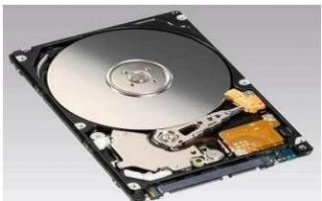

Fig 3.3 Hard Disk Drive

A hard disk drive (HDD), hard disk, hard drive or fixed disk is a data storage device used for storing and retrieving digital information using one or more rigid ("hard") rapidly rotating disks (platters) coated with magnetic material. The platters are paired with magnetic heads arranged on a moving actuator arm, which read and write data to the platter surfaces. Data is accessed in a random-access manner, meaning that individual blocks of data can be stored or retrieved in any order rather than sequentially. An HDD retains its data even when powered off.

### Software Requirements

* Operating system : Windows 7 and above.
* Coding Language : PYTHON 3.6
* Tools : Anaconda

#### PYHON:

Python is a modern computer programing language. It bears some similarities to Fortran, one of the earliest programing languages, but it is much more than Fortran. Python allows you to use variables without declaring them (i.e., it determines types implicitly), and it relies on SMART RESCUE AND SURVEILANCE ROBOT USING AI AND ML indentation as

a control structure. You are not forced to define classes in Python (unlike Java) but you are free to do so when convenient. Python was developed by Guido Van Rossum, and it is free software.

But Python is also free in other important ways, for example you are free to copy it as many times as u like, and free to study the source code, and make changes to it.

There is a worldwide movement behind the idea of free software, initiated in 1983 by Richard Stallman.

This document focuses on learning Python for the purpose of doing mathematical calculation. This assume the reader has some knowledge of basic mathematics, but this try not to assume any previous exposure to computer programming, all the some such exposure would certainly be helpful. Python is a good choice for mathematical calculations, since this can write code quickly, test it easily, and its syntax is similar to the way mathematical ideas are expressed in the mathematical literature.

#### ANACONDA:

Anaconda is a distribution of the Python and R programming languages for scientific computing (data science, machine learning applications, large-scale data processing, predictive analytics, etc.), that aims to simplify package management and deployment. The distribution includes data-science packages suitable for Windows, Linux, and macOS. It is developed and maintained by Anaconda, Inc., which was founded by Peter Wang and Travis Oliphant in 2012. As an Anaconda, Inc. product, it is also known as Anaconda Distribution or Anaconda Individual Edition, while other products from the company are Anaconda Team Edition and Anaconda Enterprise Edition, both of which are not free.

Package versions in Anaconda are managed by the package management system conda. This package manager was spun out as a separate open-source package as it ended up being useful on its own and for things other than Python. There is also a small, bootstrap version

of Anaconda called Miniconda, which includes only conda, Python, the packages they depend on, and a small number of other packages.

#### SUMMARY

This chapter tells about the all the functional, non-functional, hardware and software required for implementing the system and each requirement will be used.

### CHAPTER 4

* 1. **Design Overview**

### SYSTEM DESIGN

The system “design” is defined as the process of applying various requirements and permits it physical realization. Various design features are followed to develop the system the design specification describes the features of the system, the opponent or elements of the system and their appearance to the end-users.

### System Architecture

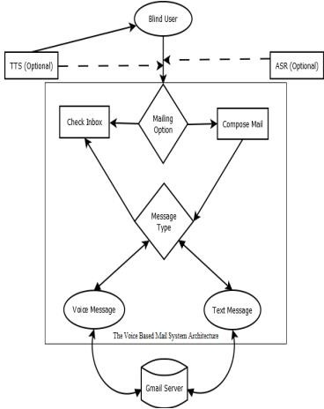

Fig 4.1 System Architecture

The diagram shows the major components of the present system, which are:

* User selection module • Mailing options: Compose or Check Inbox
* Accessibility options: text based messages or Voice based messages
* The Interactive GUI framework: An interactive GUI with voice based feedback to key press operations that supports a Blind person to access G-Mail efficiently.
* Mouse click based accessibility for the desktop framework.

### Data Flow Diagrams

A data-flow diagram is a way of representing a flow of data through a process or a system (usually an information system). The DFD also provides information about the outputs and inputs of each entity and the process itself. A data-flow diagram has no control flow — there are no decision rules and no loops. Specific operations based on the data can be represented by a flowchart. The data-flow diagram is a tool that is part of structured analysis and data modeling. When using UML, the activity diagram typically takes over the role of the data- flow diagram. A special form of data-flow plan is a site-oriented data-flow plan.

### Data Flow Diagram - Level 0

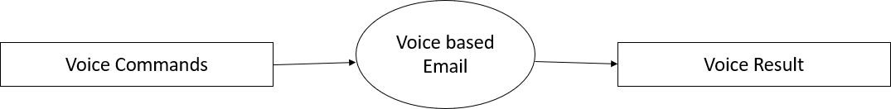

Fig 4.2 Data Flow Diagram –level 0

**Level: 0** describes the overall process of the project. We are using voice as input. System will use Google speech API to recognize and convert the text to speech for the email system.

### Data Flow Diagram - Level 1

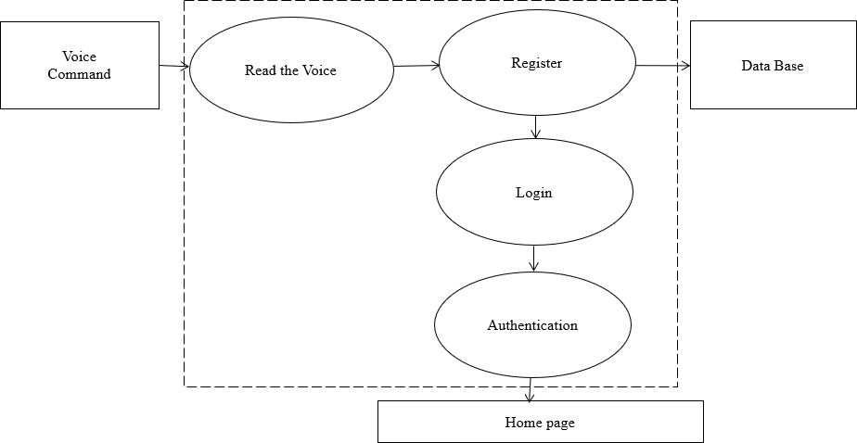

Fig 4.3 Data Flow Diagram –level 1

**Level: 1** describes the first step of the project. We are using voice as input. System will use Google speech API to read voice and store them in database and it will authenticate user.

### Data Flow Diagram - Level 2



Fig 4.4 Data Flow Diagram –level 2

**Level: 2** describes the final step of the project. We are using voice as input. System will use Google speech API to read voice convert to text as per the input given system will do the corresponding tasks.

### Use Case Diagram

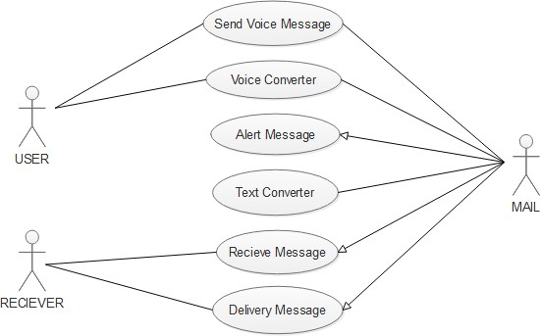

Fig 4.5 Use case diagram

### Class Diagram

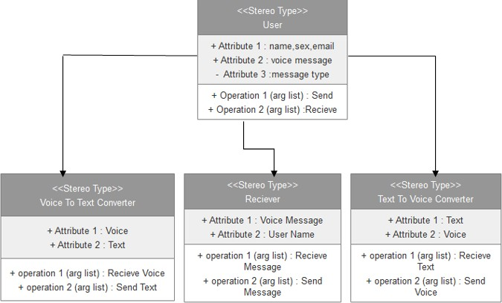

Fig 4.6 Class diagram

### Sequence Diagram

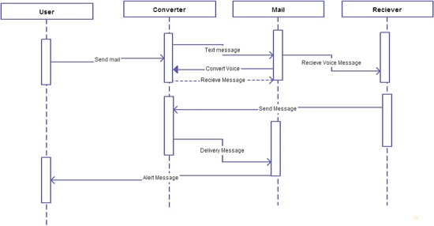

Fig 4.7 Sequence diagram

### Collaboration Diagram

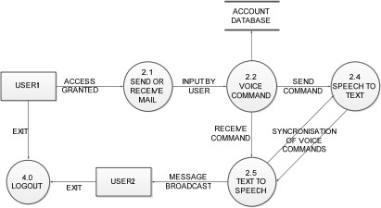

Fig 4.8 Collaboration diagram

### Activity Diagram

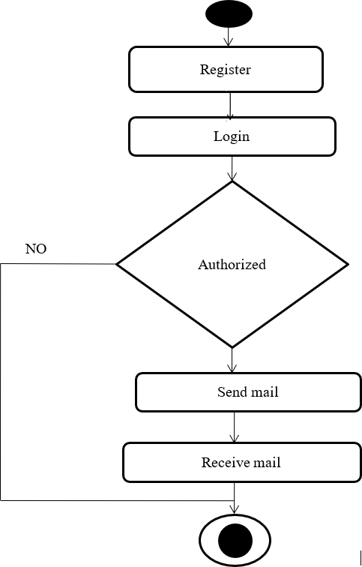

Fig 4.9 Activity diagram

### Modules

#### Registration

This is the first module of system.

Users who want to use the system should first register himself to obtain his/her own username and password.

Registration module will obtain all the details about user by voice commands given by the system that where to fill which information. The user should speak the details as the system requires.

The system captures the photo of the user for face recognition.

#### Login

This is the second module of system. Once the registration is done the user can login to the system.

Login module will ask user to provide username and password. Here the process goes in speech to text conversation of user.

User is told to validate whether he/she entered details are correct or not. Along with the user name and password our system authenticate user by his face using LBPH algorithm

,If the details are correct then the user is authorized and will enter to our application main menu.

#### Vmail APP

The user is directed to the main menu once login is done successfully. From this page now the user can perform operations that the user wishes to perform. The options available are:

Read Inbox Compose Logout

User will be guided with the help of IVR in which direction he has to move. Also there is an icon for logout, which would read as “logout” when mouse goes or rolls over it. So, when the user wants can logout from the system.

#### Compose a mail

This option helps the user view all the mails that has been received to his/her account. The user can listen to mails one by one for the after completion of every email reading it will ask do you want to continue or not? If user says yes system will read the next mail in the inbox .

#### Read the inbox

These are not only the most used mail function but also a very important feature of mailing systems. Without compose, one cannot mail.

The system is for visually challenged people and keyboard operations are completely avoided.

Composing mail is totally done on voice input(S-T-T) and mouse operations.

### SUMMARY

This chapter tells about the system design, its architecture and how data flows through each level.

Also, the how the system will work with the use of diagram and list of modules.

### CHAPTER-5

**CONCLUSION**

This project is the proposed Voice based Email system for visually impaired people, which is developed as an application which helps the blind and handicapped people to access mails easily and efficiently. It provides a voice based mailing service where the visually impaired person could read and send mail by their own without the help of others. It requires basic information about keyboard shortcuts. System has eliminated all these concepts and overcome all difficulties faced by the visually impaired. It uses a speech recognition application which provides an efficient voice input method for mailing devices for blind. It is also useful for handicapped and illiterate people.

## BIBILIOGRAPHY

1. Sharma, J. and Sharma, J., 2016. Voice Based Mail System. [online] Scribd. Available at:

<https:/[/www.scribd.com/document/306826969/voi](http://www.scribd.com/document/306826969/voice-based-mail-system)c[e-based-mail-system>](http://www.scribd.com/document/306826969/voice-based-mail-system) [Accessed 29

June 2020].

1. Amritha Suresh, Binny Paulose, Reshma Jagan and Joby George, "Voice Based Email for Blind". International Journal of Scientific Research in Science, Engineering and Technology (IJSRSET ) - Volume 2, Issue 3, 2016, pp. 93-97.
2. Milan Badigar, Nikita Dias, Jemima Dias and Mario Pinto, "Voice Based Email Application For Visually Impaired. International Journal of Science Technology & Engineering (IJSTE) - Volume 4, Issue 12, June 2018, pp. 166-170.
3. Pranjal Ingle, Harshada Kanade and Arti Lanke, "Voice Based email System for Blinds". International Journal of Research Studies in Computer Science and Engineering (IJRSCSE)- Volume 3, Issue 1, 2016, pp. 25-30.
4. Bishal Kalita and Santosh Kumar Mahto, "Voice Based Email for Blind People". International Journal of Engineering Science and Computing (IJESC) - Volume 9, Issue 10, October-2019, pp. 23789-23799.
5. Saurabh Sawant, Amankumar Wani, Sangharsh Sagar, Rucha Vanjari and M R Dhage, "Speech Based E-mail System for Blind and Illiterate People". International Research Journal of Engineering and Technology (IRJET) - Volume 05, Issue 04, April-2018, pp. 2398-2400.
6. Dudhbale, P., Wankhede, J.S., Ghyar, C.J., and Narawade, P.S., "Voice Based System in Desktop and Mobile Devices for Blind People". International Journal of Scientific Research in Science and Technology, 4, 2018, pp. 188-193.
7. Akif Khan, Shah Khusro, Badam Niazi, Jamil Ahmad, Iftikhar Alam and Inayat Khan, "Tetra Mail: A usable email client for blind people". Universal Access in the Information Society-04 September 2018.
8. Jagtap Nilesh, Pavan Alai, Chavhan Swapnil, Bendre M.R.," Voice Based System in Desktop and Mobile Devices for Blind People". International Journal of Engineering Technology and Advanced Engineering (IJETAE) - Volume 4, Issue 2, February-2014, pp. 404- 407.
9. Prof. Umesh A. Patil, Pranouti B. Patil, Teja P. Magdum, Shweta K. Goud and Latika R. Bhosale, "A Survey on Voice Based Mail System for Physically Impaired Peoples". International Journal of Innovative Research in Computer and Communication Engineering (IJIRCCE) - Volume 4, Issue 1, January 2016, pp. 1002-1006.